**This submission is original work and no part is plagiarized** (signed) _Yamini Bansal (Date)__26-08-2020



**MECHANICAL ENGINEERING DEPARTMENT**

**Thapar Institute of Engineering and Technology, Patiala**

**Assignment - 2.**

**Dynamics for the Mangonel-With Drag**

***UTA013 Engineering Design Project-I***

Submitted by:

Name: Yamini Bansal

Roll No: 102003446

Group: 2CO17



**Assignment - 2.**

**Dynamics for the Mangonel-With Drag**

The following tasks have been based on the lecture on projectile dynamics for the Mangonel -**With Drag**.Complete the following **individually, copying will be dealt with severely.**

**Notes:**

1. Ensure the curves are visible and sufficient resolution is provided so that the height and distance is determinable. Keep scale of x-axis and y-axis roughly the same, e.g. 10m on x-axis and y-axis should be forming a square. The following chart is an example for 80 degrees at 30m/s.

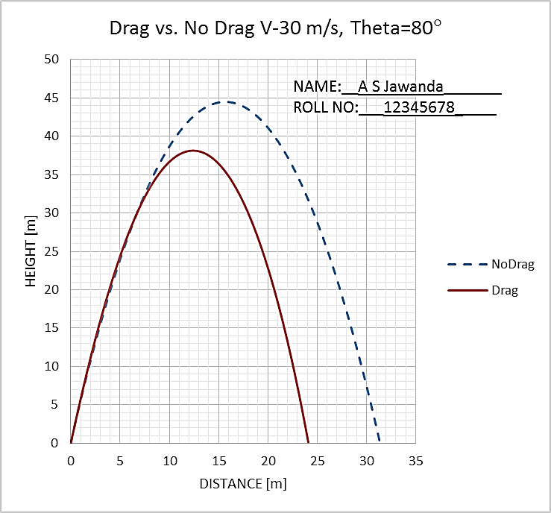

**Note:Compulsory** to Add Text box of Name and Roll No to every graph as shown.

1. The excel graphs for Drag Vs No Drag Velocity=20m/s, Angle=50 degrees have to be shown for evaluation on the same day. While the print of this word document with **graphs(with Name and Roll No in text box)** and **hand written conclusions, name & roll number on every page**, stapled together, is to be submitted in next Tutorial class (if it is a holiday, then as instructed).
2. Do not leave this assignment until the last minute to find you have some IT issue.

Enjoy the assignment and try to think around the subject as much as possible and take from it any tips that you might use with your own Mangonel design.

**Marking Scheme:**

**Tutorial 1 Total = 10 Marks**

**Evaluation at end of 2 Hours Tutorial =2.5**

**Home Evaluation= 2.5**

**TUTORIAL CLASS EVALUATION**

**Plot graph for Drag Vs No Drag. Velocity=20m/s, Angle=50 degrees.**Use rho=1.2 kg/m^3, Cd=0.4, mass=0.05kg, D=0.045 m.

**Only Q1a below evaluated at the end of 2 Hours of tutorial class on computer.**

**Point five Marks each for: [2.5 Marks]**

1. Excel sheet formulation,
2. Layout,
3. Graph double series for Drag vs No Drag,
4. Graph clarityand
5. Graph format, as given in note.

***NOTE: Compulsory*** *to Add Text box of Name and Roll No to every graph as shown.*

Save this word document adding your name and roll number to the front page. Using the Excel spreadsheets that you have developed in class to model the dynamics of a “missile” cast by the Mangonel which is subject to aero-dynamic drag, cut and paste charts for the following parameters into the document below:

1. Use rho=1.2 kg/m^3, Cd=0.4, mass=0.05kg, D=0.045 m.
   1. Drag Vs No Drag. Velocity=20m/s, Angle=50 degrees

**Soft copy evaluated at the end of 2 Hours of practical class on computer.**

* 1. Drag Vs No Drag. Velocity=20m/s, Angle=80 degrees
  2. Drag Vs No Drag. Velocity=20m/s, Angle=20 degrees

1. Read, from the figures determined in Q1 or directly from the results calculated using your spreadsheets, the predicted max. horizontal distances travelled (in the x-direction when y = 0 approx.) for the “drag” and “no-drag” cases. Complete the following table with **hand written values**. Round your results to nearest integer (no decimal places).

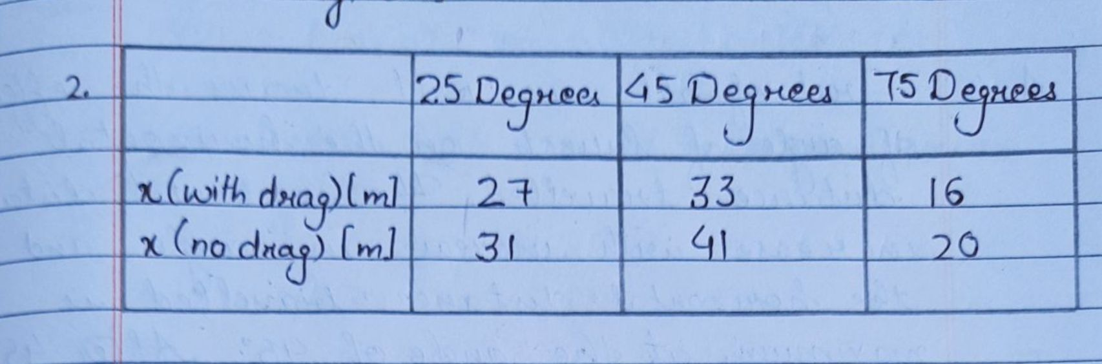

1. Complete the following table by **hand written values** for the maximum distance travelled in x. Use values rho=1.2 kg/m^3, mass=0.05kg, D=0.045m, theta=45degrees in this question.

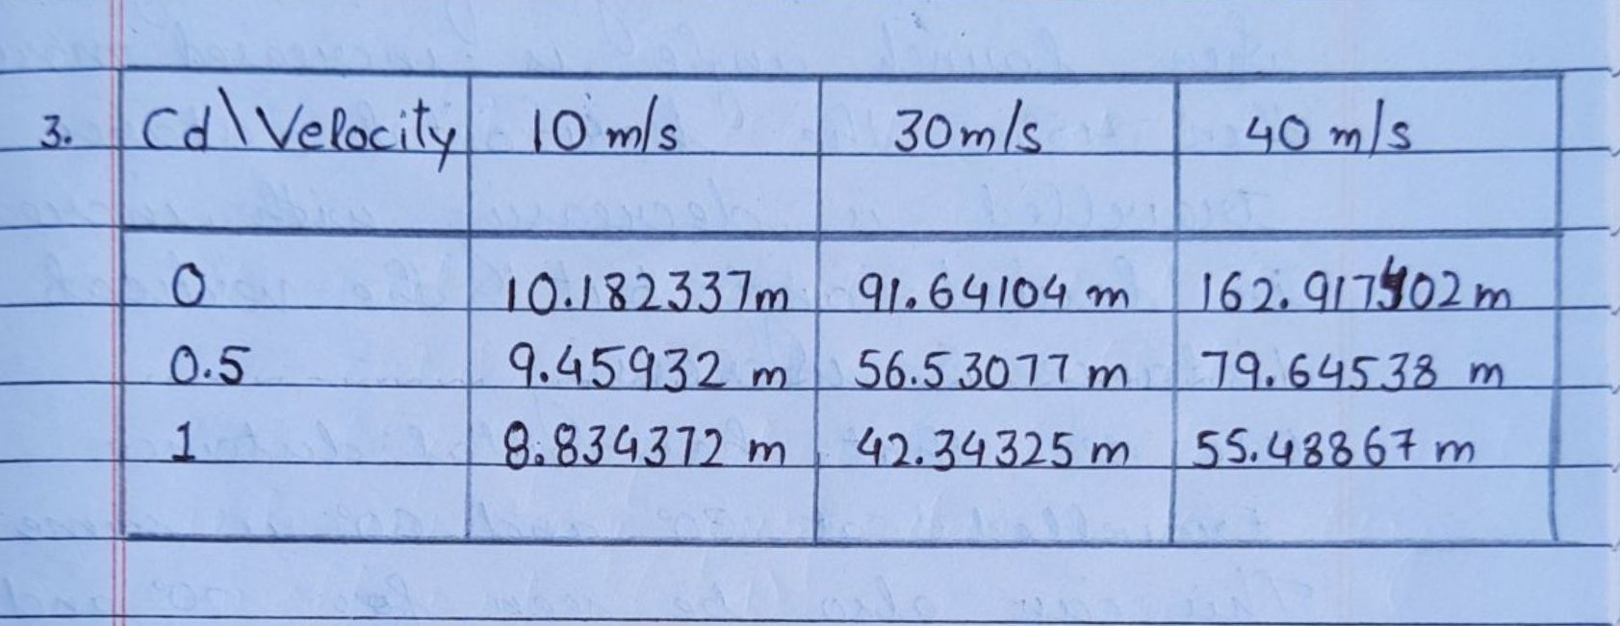

1. Complete the following table by **hand written values** for the maximum distance travelled in x. Use values rho=1.2 kg/m^3, Cd=0.4, D=0.045m, Theta=45degrees in this question.

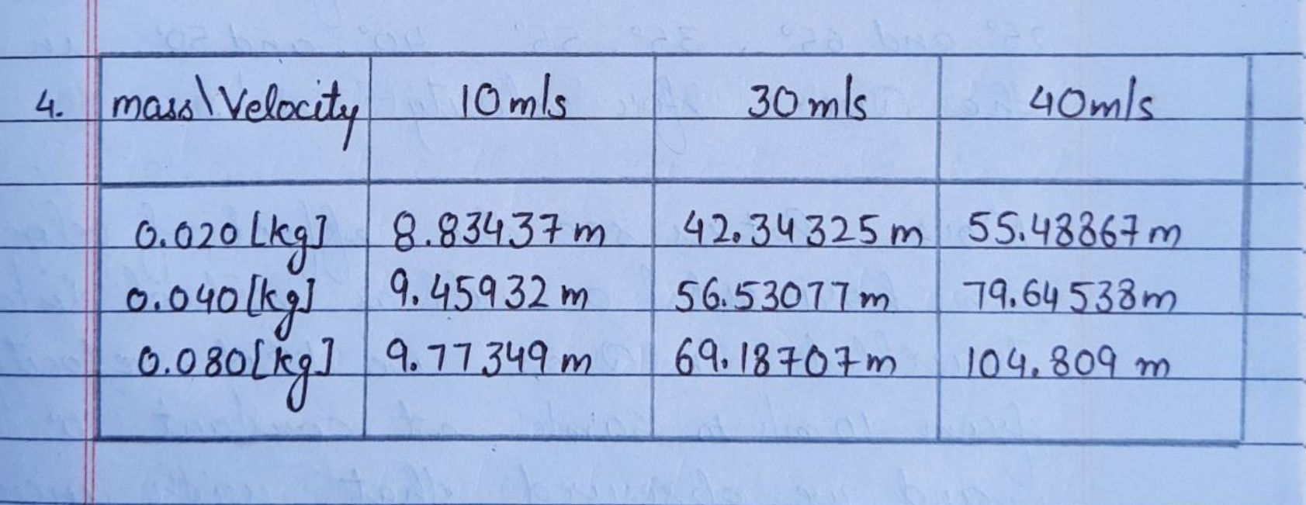

1. For a 30m/s launch velocity, taking the values rho=1.2 kg/m^3, Cd=0.4, mass=0.05kg, D=0.045 m find the maximum horizontal distance of travel for launch angle varying from 20 to 70 degrees and record **hand written values** in table below. Plot the graph and use it to find the angle of launch which would give maximum horizontal distance of travel.

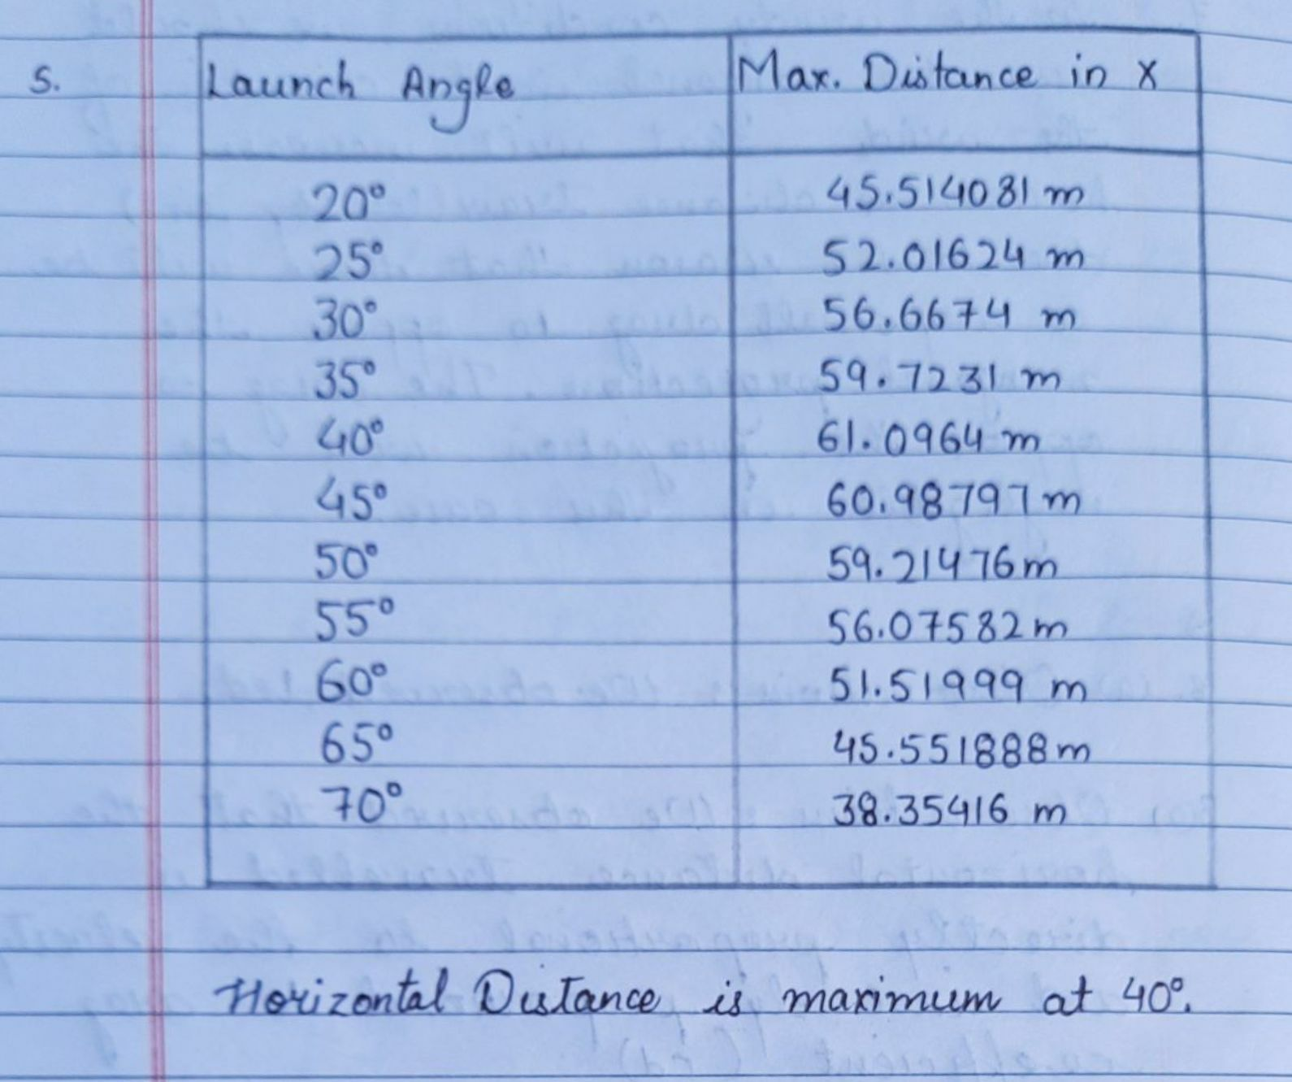

**NOTE:** Answers to Q6,Q7, Q8, Q9 and Q10 to be **hand written only**

**[5 Marks]**

1. From the results of question 2, write one or two sentences to address each of the following:

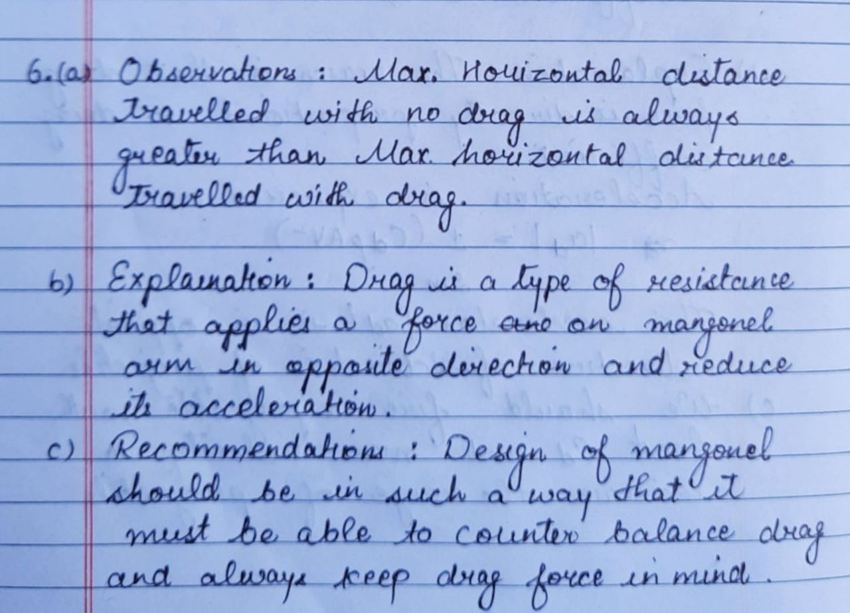

1. If we were to test the mangonel outside in windy conditions, what comments have you to add based on the above analysis in question 6.

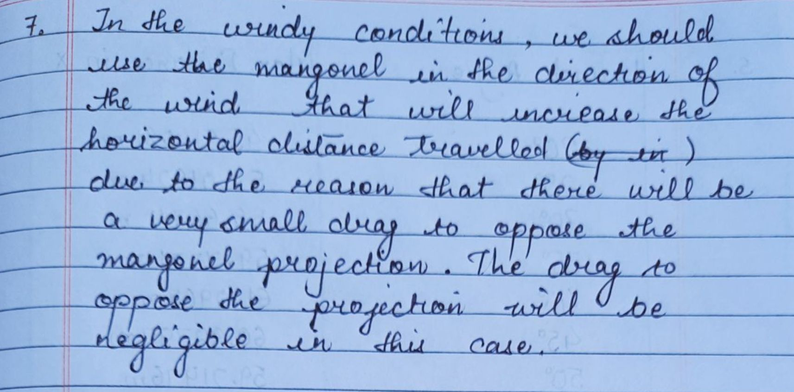

1. From the results of question 3, write one or two sentences to address each of the following;

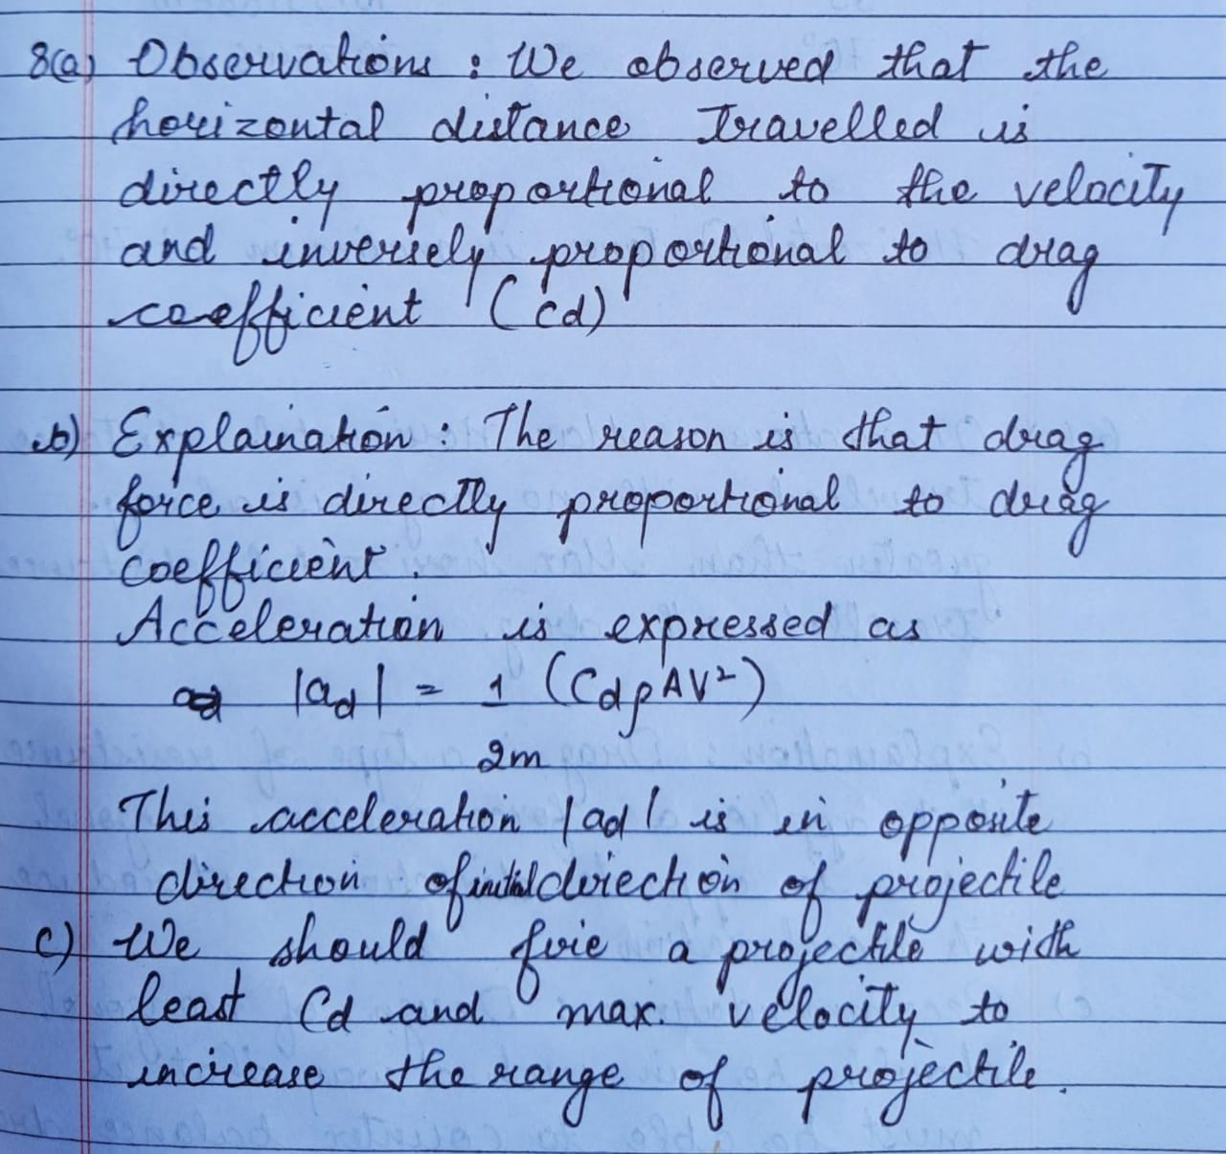

1. From the results of question 4, write one or two sentences to address each of the following;

(c) Recommendations with regards to the optimum use of the Mangonel. For this last point, consider the effect of a change in mass when all other aerodynamic and physical parameters remain fixed, e.g. the potential energy stored in the “spring”:

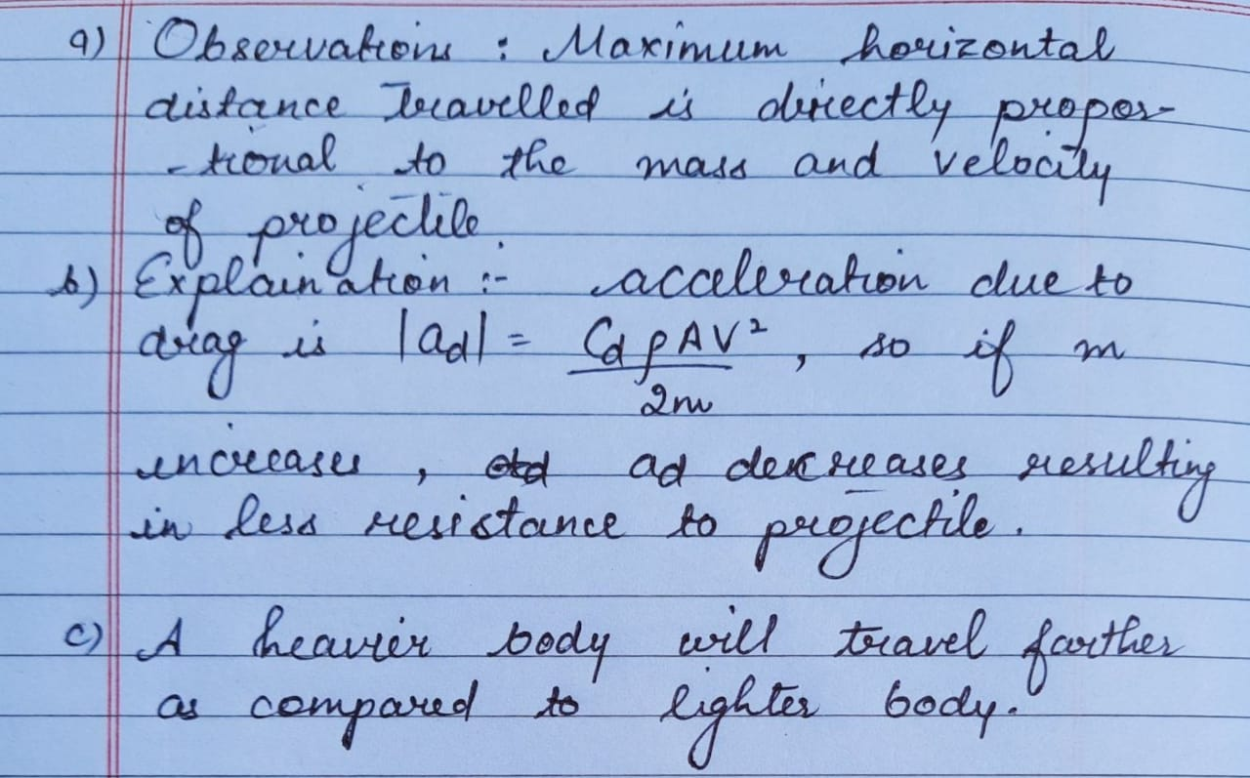

1. From question 5 angle of launch which would give maximum horizontal distance of travel is:

